# Lab – 1 Basic Programming Practices

Tasks:

**Python Shell**

1. Open the **Python** Shell

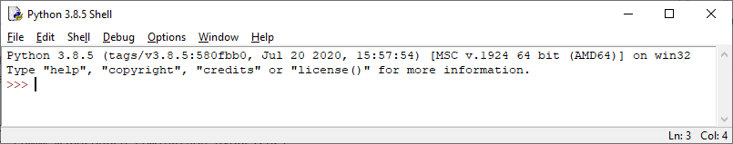

1. Type **1+1** after the >>> sign
2. Try to print a statement by typing **print("hello World!")** after the >>> sign

**Python Script**

1. Create a new python program called **lab01_q04.py** (File 🡪 New File) or (Ctrl + N) and enter the following code segment. Save this program by File 🡪 Save or (Ctrl + S) and enter lab01_q4 in the File name field (file extension .py is optional)

total = 1 + 1

print (total)

Output:

2

1. Select Run 🡪 Run Module or (press key F5) to run this program
2. Modify your previous program as follows, save it to another name called **lab01_q06.py** (File 🡪 Save As…)

total1 = 1 + 3 + 5 + 7 + 9

total2 = 2 + 4 + 6 + 8 + 10

print ("1 + 3 + 5 + 7 + 9 =", total1)

print ("2 + 4 + 6 + 8 + 10 =", total2)

print ("1 + 2 + ... + 9 + 10 =", total1 + total2)

Output:

1 + 3 + 5 + 7 + 9 = 25

2 + 4 + 6 + 8 + 10 = 30

1 + 2 + ... + 9 + 10 = 55

1. Let a = 1 and b = 2. With reference to the previous program, generate the following sample output. Save the program as **lab01_q07.py**

Output:

a + b = 3

a - b = -1

a * b = 2

a / b = 0.5

Answer:

a=1

b=2

print ( "a + b =" , a + b)

print ( "a - b =" , a - b)

print ( "a * b =" , a * b)

print ( "a / b =" , a / b)

1. Print the following sentence by calling the print() function once. Save the program as **lab01_q08.py**

Output:

In Python, sequence of characters is included inside 'single quotes' or "double quotes". As far as language syntax is concerned, there's no difference in 'single quoted' or "double quoted" string. Both representations can be used interchangeably. However, if either 'single quote' or "double quote" is a part of the string itself, then the string must be placed in "double quotes" or 'single quotes' respectively.

Answer:

output = "In Python, sequence of characters is included inside 'single quotes' or "

output = output + '"double quotes". '

output = output + "As far as language syntax is concerned, there's no difference in 'single quoted' or "

output = output + '"double quoted" string. Both representations can be used interchangeably. '

output = output + "However, if either 'single quote' or "

output = output + '"double quote" is a part of the string itself, then the string must be placed in "double quotes" or '

output = output + "'single quotes' respectively."

print (output)

Answer:

print ("In Python, sequence of characters is included inside 'single quotes' or \"double quotes\". As far as language syntax is concerned, there's no difference in 'single quoted' or \"double quoted\" string. Both representations can be used interchangeably. However, if either 'single quote' or \"double quote\" is a part of the string itself, then the string must be placed in \"double quotes\" or 'single quotes' respectively.")

Note: Hints are given in output. You can also have a look about **escape character** in lecture notes chapter 2

1. Write a program to ask user’s input of their name and say hello to them. Sample output is provided as below. Save the program as **lab01_q09.py**

Output:

What is your name? Kelvin

User’s input

Hello Kelvin

Answer:

name = input ("What is your name? ")

print ("Hello "+ name)

1. i) State the total number of students calculated by the following program and user’s input

class_a = input ("How many students are there in class A? ")

class_b = input ("How many students are there in class B? ")

print ("Total number of students from class A and B is", class_a + class_b)

Output:

How many students are there in class A? 28

User’s input

How many students are there in class B? 32

Total number of students from class A and B is __

Answer:

2832

ii) Try to modify the above program to give a reasonable output. Save the program as **lab01_q10.py**

Answer:

class_a = int(input ("How many students are there in class A? "))

class_b = int(input ("How many students are there in class B? "))

print ("Total number of students from class A and B is", class_a + class_b)

Note: the return value of input function is **String**. You may have a look about **data types** in lecture notes chapter 2